

Mini Project Report
of
Database Systems Lab (CSE 2262)

RESTAURANT MANAGEMENT SYTEM

SUBMITTED
BY

Viraj Chetan Desai 210905019
Sanjaya C Bhat 210905010

Department of Computer Science and Engineering
Manipal Institute of Technology, Manipal.

DEPARTMENT OF COMPUTER SCIENCE & ENGINEERING

Manipal
09/05/2023

CERTIFICATE

This is to certify that the project titled RESTAURANT MANAGEMENT SYTEM
is a record of the bonafide work done by Viraj Chetan Desai (210905019) and
Sanjaya C Bhat (210905010) submitted in partial fulfilment of the requirements for the award of the Degree of Bachelor of Technology (B.Tech.) in COMPUTER SCIENCE & ENGINEERING of Manipal Institute of Technology, Manipal, Karnataka, (A Constituent Institute of Manipal Academy of Higher Education), during the academic year 2022-2023.

Name and Signature of Examiners:

- Sucharitha Shetty, AssociateProfessor, CSE Dept.

TABLE OF CONTENTS

ABSTRACT

CHAPTER 1: INTRODUCTION

CHAPTER 2: PROBLEM STATEMENT & OBJECTIVES

CHAPTER 3: METHODOLOGY

CHAPTER 4: RESULTS & SNAPSHOTS

CHAPTER 5: CONCLUSION

CHATER 6: LIMITATIONS & FUTURE WORK

CHAPTER 7: REFERENCES

ABSTRACT

The restaurant industry is highly competitive, and managing a successful restaurant requires efficient and effective management of various resources such as inventory, orders, employees, and customer data. To achieve this, a Restaurant Management System (RMS) can be developed using a Database Management System (DBMS) to automate many restaurant processes, providing an integrated solution to manage various aspects of restaurant operations.

The main objective of this DBMS project is to design and develop a Restaurant Management System that can be used to manage various restaurant operations such as order management, inventory management, and customer management. The system will allow restaurant owners to view real-time data and make informed decisions to optimize operations.

The project will involve creating a database schema, implementing CRUD (Create, Read, Update, Delete) operations, designing a user interface for the restaurant staff, generating reports, and implementing security features to protect sensitive data. The system will also incorporate features to manage menu items, table reservations, and payments.

Overall, the Restaurant Management System will streamline restaurant operations, increase efficiency, reduce errors, and improve the customer experience.
INTRODUCTION

Flutter based application, using firebase and MySQL for data storage and PHP as backend using XAMPP server.
Greeted with a login / sign up page for users, and also can be redirected to administrator login.
Has functionality to sign up in using PHP API which sends required information to store in MySQL. Using another API, we retrieve the information from MySQL to check and authenticate existing user allowing them inside the application.
Similarly, an administrator can login but not sign up into the application for security purposes.
The administrator has the ability to perform all CRUD operations which include the ability to add new items into the menu, remove items from the menu and update the prices.
In order to maintain the size of the application all images are hosted on firebase from the admin upload screen, and retrieved using PHP whenever required.
The User has the ability to check all the products available and customize their order.
METHODOLOGY
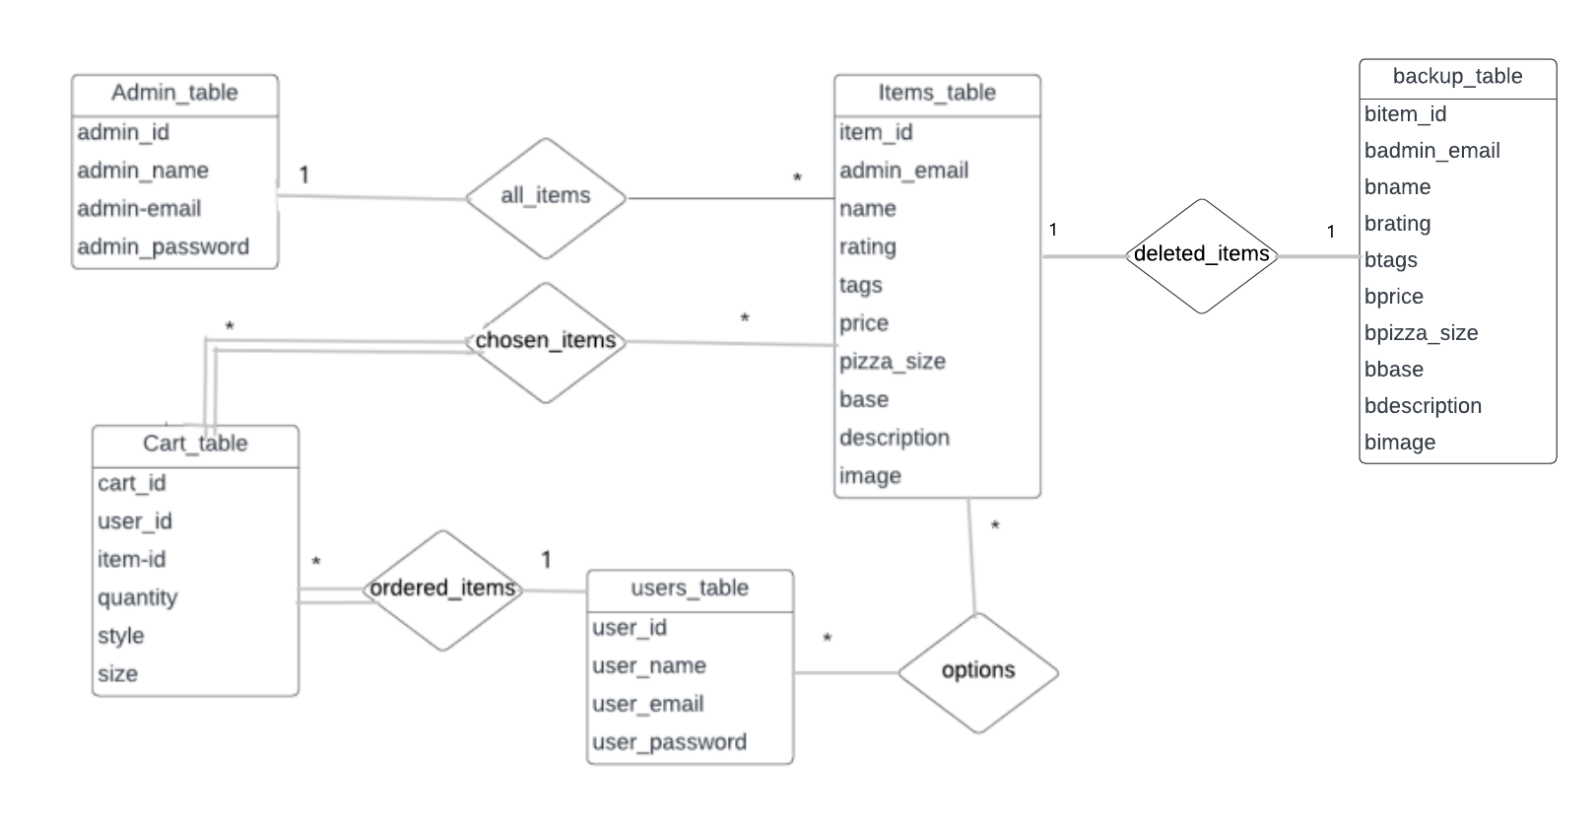
The methodology for developing the Restaurant Management System can follow the Agile methodology, which involves an iterative and incremental approach to software development.
Planning: Defining the scope and objectives of the system, identify the requirements, and prioritizing them based on their importance and feasibility.
Design: Creating the database schema, user interfaces, and functionalities.
Implementation: Implement the system using PHP as the server-side language, MySQL as the database management system, and Firebase for image hosting.
Deployment: Deploying the system on a server and make it accessible to users.

The development process should involve regular feedback from customers, to ensure that the system meets their needs and expectations. Additionally, prioritizing the security features, such as encryption, to protect sensitive data from unauthorized access.
RESULTS AND SNAPSHOTS

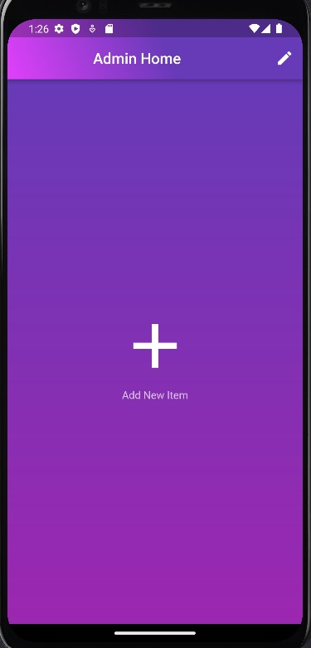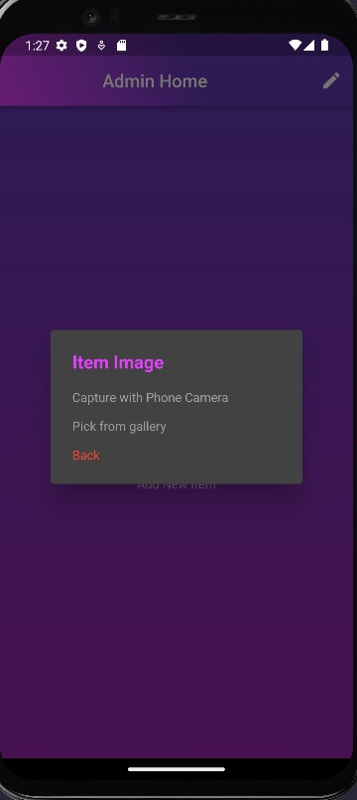
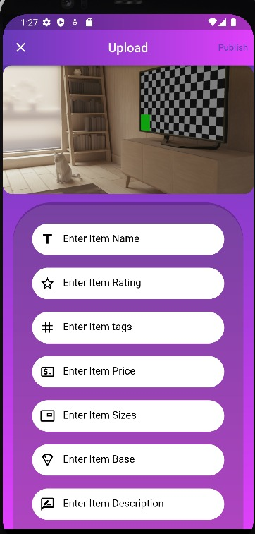
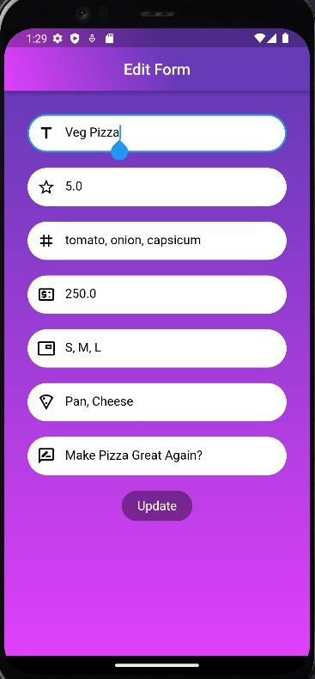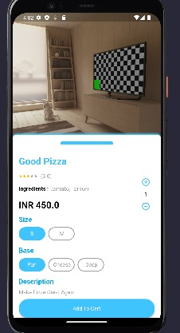
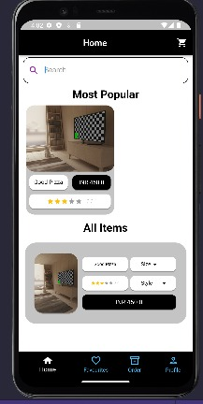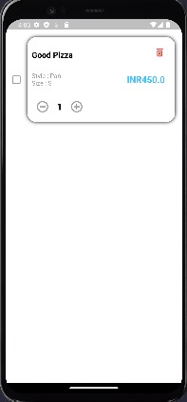
CONCLUSION

In conclusion, the Restaurant Management System is an effective tool for managing restaurant operations and improving the customer experience. The system provides a user-friendly interface that allows users to easily browse through the menu, customize their orders, and submit them.

The use of PHP API and MySQL database management system ensures that the system is efficient and reliable, while the integration with Firebase for image hosting helps maintain the application's size. The authentication process ensures that user data is secure and that only authorized individuals have access to the system.

The system's administrator login provides access to CRUD operations, allowing for easy management of the menu items, their prices, and their availability. This feature allows restaurant staff to easily update the menu based on customer feedback and changing market trends.

Overall, the Restaurant Management System is an effective solution that helps streamline restaurant operations, improving efficiency, accuracy, and customer satisfaction.
LIMITATIONS AND FUTURE WORK

One limitation of this Restaurant Management System is that it currently only supports one restaurant. In the future, it could be expanded to support multiple restaurants, with different menus and pricing options.

Additionally, the system does not include a feature for tracking the status of orders. Future work could include adding a feature that allows customers to track the progress of their orders, from preparation to delivery.

Finally, the system does not currently include a reporting feature for restaurant staff to track sales and other metrics. This could be a valuable addition to help restaurant owners make data-driven decisions to improve operations and profitability.

In summary, while the Restaurant Management System is a useful tool for managing restaurant operations, there is always room for improvement and expansion.
REFERENCES

https://github.com/VirajChetanDesai/ThePizzeriaFlutter
https://docs.flutter.dev/
https://www.php.net/docs.php
https://www.lucidchart.com/pages/

